# SimpleTop

## What is SimpleTop?

It’s a Tabletop Roleplaying Game that is easy to play and easy to customize for newcomers and seasoned roleplayers!

## How do I play with it?

Start by gathering a group of friends to play with!  
One or more of the friends acts as the GameMaster(s) (or GM). Anyone who isn’t a GM or a curious onlooker is a Player.

GMs narrate the events of a story and the outcomes of player actions. They also generally handle the behaviors of the story’s antagonists. Players help build this story out by acting as characters within the story, interacting with the world, and roleplaying with each other. Your group of friends decides what kind of characters to play, and how to behave together.

## What kind of setting is it for?

SimpleTop is designed with customization in mind! You can play any game in any setting at any kind of power level.

## What about magic?

SimpleTop has no explicit rules about magic! This means that you can have the same abilities as other Players but describe them as magical spells that you cast. Your group can also create your own rules for magic if you want.

## What do I need to play?

If you have this rulebook, you don’t need anything else to start playing! Having at least some 6-sided dice, pencils, and paper will make it much easier, though.

# Table of Contents

### Character Creation - - - - - -

### Playing SimpleTop - - - - - -

### Combat Basics - - - - - - - - -

### Roleplaying Basics - - - - - -

### Custom Rules - - - - - - - - - -

### Help for the GM - - - - - - - -

### Zones - - - - - - - - - - - - - - - -

### Sessions & Gameplay - - -

### Creating Combat - - - - - - -

### Creating a Story - - - - - - - -

### Sample Characters - - - - - -

### Sample Enemies - - - - - - - -

### Sample Items - - - - - - - - - -

### Pg. 4

### Pg. 6

### Pg. 8

### Pg. 10

### Pg. 12

### Pg. 14

### Pg. 16

### Pg. 18

### Pg. 20

### Pg. 22

### Pg. 24

### Pg. 26

### Pg. 28

# Special Thanks

**♥** You **♥**

# Character Creation

## The 5 Ws

* When thinking about a character, it can be helpful to ask yourself the 5 Ws:
  + **Who?** Who is your character and who do they want to be? Who do they consider family?
  + **What?** What does your character look like? What’s important to them physically and emotionally?
  + **When?** When in their life are they adventuring? Are they young or old? Is this their first job? What life events have recently happened to them?
  + **Where?** Where is your character from? Where are they trying to go? Where have they been?
  + **Why?** Why does this character exist? Why are they a part of this group?
* This is useful for creating player characters and NPCs

## Starting Items

* All characters start with whatever weapons they want!
  + Think about at least 1 close-range weapon and   
    1 far-range weapon
* They also start with 2 Potions and other Items you think makes sense for their background
  + 1 **Fast Potion** and 1 **Potion** (see *Sample Items*)
  + Discuss other Items with your GM
* Basic adventuring Items are assumed to be had by someone in your party (like rope, ammo, or torches)



**Example**

Longsword that glows with an eternal fire, a bow with arrows, a necklace from my mother, and a child’s toy.

## Actions, Abilities, & Stats

* Actions are underlined
  + Things you can do in Combat
* *Abilities* are italicized
  + Passive Buffs that are always active
* Each Stat has 6 blocks with Actions & *Abilities*
* You’ll usually start at Level 1, gaining 4 SP to put into whichever Stat(s) you want (see *Stats & Leveling Up*)

**Strength:** How powerful you are, or how easily you surpass your mental barriers.

In combat, this increases Health and damage.

**Skill:** How in touch you are with your inner power.

In combat, this provides a variety of Actions.

**Support:** How in touch you are with who, or what, is *around* you.

In combat, this heals and blocks damage.

**Scharisma:** How personable or persuasive you are.

In combat, this can change rolls and heal

# Playing SimpleTop

## What’s a Session?

A session is a chunk of time set aside to roleplay with your friends! Each session has chunks of different types of gameplay, like Storytelling, Exploration, Roleplaying, and Combat. As you experience these different elements of gameplay, tell your GM how you feel about them so they know how you like to play; remember that your feelings on each of these will change over time.

## What do I do?

Roleplaying games can be overwhelming with how much freedom you have, so giving yourself constraints can help you come up with things to do. Think about your character, who they are, and what they want to do, or think about what you want to do as a player.

* Think about your character
  + What are their goals? Can they progress toward them?
  + How do they feel about recent events?
  + How would they support other characters in the group?
* Think about you as a player
  + Are you curious about something the GM just said?
  + Do you want to engage with a specific kind of NPC?
  + Do you want to roleplay with a character in the group?

## What if I forget a rule?

Who cares? If you forget a rule, ask your GM about it, or just focus on roleplaying your character and your GM will let you know about any rules that deal with what you’re trying to do.

# Other Good Things to Know

## Dice

* [A qr code on a white background

  Description automatically generated](https://rolladie.net/)Xd6 means X number of 6-sided dice
* If you don’t have dice, use a site like [rolladie.net](https://rolladie.net/)

## Rounding

* Round up (1.5 counts as 2)

## A black and white circle with numbers Description automatically generatedStats & Leveling Up

* Players have 10 max Health per Level
* Players have 4 Stat Points (SP) per Level
* Distribute SP into Stats from top to bottom
* When you level up, distribute your new SP into whichever Stat(s) you want!
* To unlock all Actions & *Abilities* inside a Stat Block,  
  put 1 SP in that Block
  + For example, having 7 SP in Strength allows you to use **Splash Attack**
* To put SP in a Block, there must be 6 SP in the Block above it
  + The bottom block of each Stat has no SP limit!

## Session Zero

Session Zero is a special session where all players discuss topics they’re comfortable roleplaying, player relationships, and their expectations for the gameplay. This is a fantastic time to discuss what kind of character you want to play and how they’d fit in with the other characters.

# Combat

## Phases

* Combat generally starts with the Enemy Phase
  + GM describes enemy behavior
  + Some Actions can be used by Players
* Players and their Allies act during the Player Phase

*Health

* Players have 10 max Health per level
* If you reach 0 Health, you can’t contribute to the current fight or be healed
  + This does not have to mean death
  + **Phoenix** and **Revival** can bring you back into the fight!

## Healing Out of Combat

* Your GM tells you how to heal after combat ends

## Actions & Action Points

* Actions are underlined
* Spend Action Points (AP) to do Actions
* All players have 5 max AP
* AP is restored at the start of the Enemy Phase
* Actions cannot go through hard Zone boundaries ( ), but have no explicit range (so **Attack** can shoot over long distances, if you want it to!)
  + Using an Action on a target in another Zone requires a direct line of sight without going through a hard Zone boundary ( )

## A black background with a black square Description automatically generated with medium confidenceMovement

* Move freely in your Zone (the Zone you’re currently in)
* Spend 1 AP to move to a touching, accessible Zone
* Zone size & placement are defined by GM
* Hard Zone boundaries ( ) block Actions and Movement

## A white and black symbol of a bottle with a tag Description automatically generatedUsing Items

* Items are Fast, Normal, Slow, or Special
* Spend 1 AP to use a Fast Item
* Spend 2 AP to use a Normal Item
* Spend 3 AP to use a Slow Item
* Spend 4 or more AP to use a Special Item
* AP Cost and Item Effects are specified in their Description

## Roleplaying in Combat

* To do something that isn’t listed as an Action, like pulling a lever or grappling an enemy, Roleplay it!
* Spend 1 AP to Roleplay in Combat
* Roll 1d6 and add the highest, unlocked Roleplay Bonus for the Stat you’re rolling

# Roleplaying

## Roleplay Bonus

* Tell GM you want to do something
  + You can ask to do something with a specific Stat
* If requested, roll a d6
* Add the highest, unlocked Roleplay Bonus from the Stat
* If you roll at least the Goal, you and your GM work together to roleplay the outcome

**Example**

Player: “I’d like to grab the treasure without triggering the trap.”

GM: “Give me a Skill roll with a Goal of 4.”

Player rolls 1d6 and gets a 3.

Player then adds their Roleplay Bonus of 2 for a total of 5.

GM: “The magical gem seems to float towards you, beckoning to you. How do you grab it?”

## Player-Versus-Player Rolls

* Rolls that Players do against each other
* Ask for consent before doing these!

## Competing Rolls

* 2 or more Characters try to do the same thing
* A Character tries to do something to another Character
* Both Characters roll
  + Non-Players don’t get Roleplay Bonuses
  + Higher roll gets to do the thing
* **Players don’t need to use the same Stat

**Example**

John: “I grab the treasure.”

Cristy: “Wait, I want treasure, too! I try to swipe it from him!  
Is that okay John?”

John: “Lol, yeah, you’re good, but I’ve got a firm grip on it.”

GM: “Competing Rolls! John roll Strength, Cristy roll Skill.”

John: Rolls a 5.

Cristy: Rolls a 4.

John gets the treasure.

## Ties

* GM’s Discretion
  + Nothing happens
  + Roll again
  + Custom Rule

**Example**

John: Rolls a 5

Cristy: Rolls a 5

GM: “Okay, I don’t want to make you roll again, so I’ll say John hangs onto it since he disarmed the trap blocking it.”

John: “I’ll split the cash we get for it though!”

Cristy: “Thanks John!”

# Custom Rules (optional)

## Creating a Custom Rule

* Make up your own rules, that’s what this was made for!
* Discuss the custom rule(s) with the group
* Write them where everyone can reference them

## Sample Custom Rules

* Super 6
  + Roll 2d6 when Roleplaying
  + Rolling two 6s means something awesome happens!
  + 2.5% chance
* Resting
  + Players rest out of combat to heal
  + Roll 1d6 per hour of rest, then heal that much Health
* Death Rolls
  + Every Player Phase after you reach 0 Health, roll 1d6
  + Roll an even number: nothing happens
  + Roll an odd number: character dies
* Weighted Inventory
  + Players can carry 1 Item per Stat Point in Strength
* Permanent Wounds
  + Reaching 0 Health creates a permanent scar or dismemberment

## Custom Rules

# General Help for the GM

## Roleplaying

* Discuss situations your group is comfortable with
* Work with Players to tell a story, not against them
* Connect characters and the story to Players through their motivations, personal objectives, and decisions

## Asking For Rolls

**Suggested Goals**

Very Easy: 3

Easy: 4

Kind of Hard: 5  
Hard: 7

Extremely Hard: 9

Heroic: 10

Almost Impossible: 12

Not everything a Player does needs to be rolled. Ask Players to roll if they try to do something difficult or that they wouldn’t normally be proficient in.

* Clarify Player Intentions
  + “So, you want to break open the rusted, metal door?”
* Create a Goal the player tries to meet or beat
* Ask them to roll based on a Stat you think is relevant, or one they request
  + “Give me a Strength roll, with a Goal of 5.”
* Player rolls 1d6 and adds the Stat’s highest, unlocked Roleplay Bonus
* Player succeeds by rolling the Goal or higher
* Roleplay the outcome with the Player
  + “You did it! How do you bust into the room?”

Strength represents power and will.

Skill represents proficiency and introspection.

Support represents extrospection and medicinal prowess.

Scharisma represents social aptitude and conspicuousness.

Mental or magical prowess could be represented by any Stat.

## Inventory

* No explicit rules for inventory management
* Discuss a custom system or ignore it entirely
* Players will be creative with Items, don’t be afraid to say no for the sake of the story

**Magic**

No explicit rules exist for magic.

Players can describe Actions as spells, but for specific rules and effects, feel free to discuss a custom system!

## Encounters

* Roleplay Encounters
  + Show players the consequences of their decisions.
  + Give players a creative problem to solve
* Combat Encounters
  + Teach/challenge players on game mechanics
  + Whittle down player resources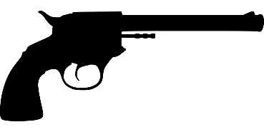

## Combat

* Not required. You can have a fun game without combat!
* Starts with Enemy Phase, followed by the Player Phase
  + Describe Enemy behavior, deal damage with rolls
* Player Phase: Players describe their Actions
  + Players can act at the same time
* If all players reach 0 Health, they lose that fight
  + Doesn’t need to mean death
  + Maybe enemies steal loot or their plan works
* After Combat, it’s normal to completely heal Players
  + Don’t heal them for an extra challenge.

# About Zones

## Zones

* You define Zones
  + Size and boundaries of each Zone
  + “Your Zone” refers to the Zone you’re currently in
* Zones don’t need to be equal size
* Soft boundaries separate accessible Zones
  + Represented by dashed (**- - - - -**) lines
* Hard boundaries block movement and Actions
  + Represented by solid ( ) lines
* Zones can touch without being accessible to each other

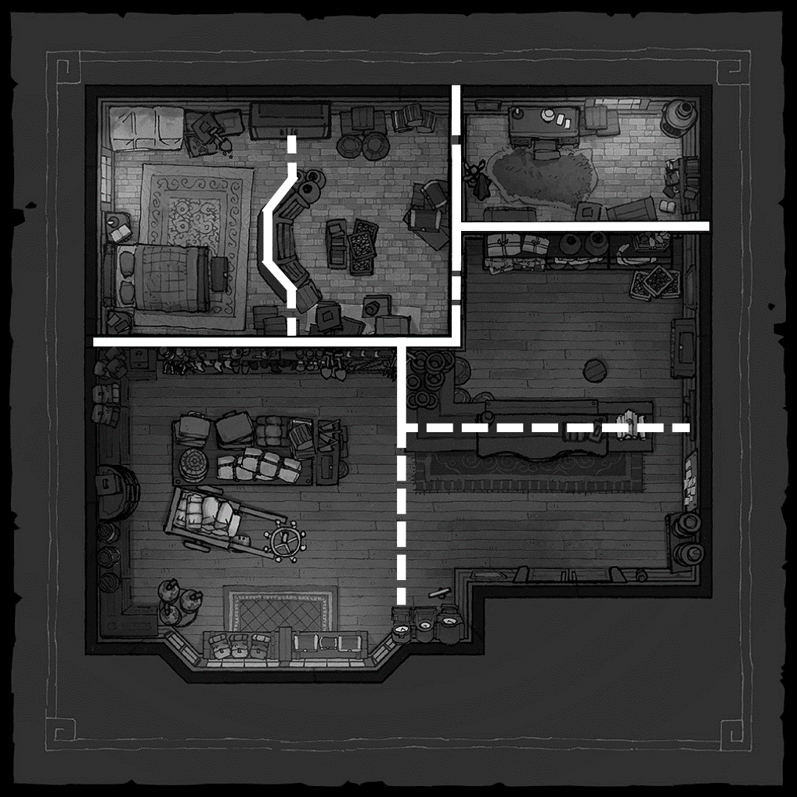

## Cover (optional)

If you want to add some extra tactical elements to your combat, you can add cover!

* Represented by wiggly (**~~~~~**) lines
* Affects damage from a direct line of sight that intersects the Cover
* During the Player Phase, Players can freely move to Cover in their Zone
  + During the Enemy Phases, they can spend 1AP to move into Cover in their Zone
  + Damage taken is reduced by their Level
* During the Enemy Phase, enemies can freely move to Cover in their Zone
  + Can’t move into Cover during the Player Phase
* A black background with a black square

  Description automatically generated with medium confidenceIn this example, the Level 5 Player ( ) is in Cover
  + A map of a room

    Description automatically generated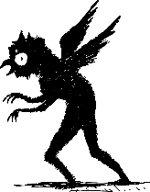When the shadow monster ( ) attacks, the Player takes full damage
  + 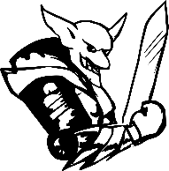When the   
    goblin ( ) attacks, the Player reduces the damage by 5 (their Level)

# Sessions & Gameplay

## Sessions

* Sessions are like “episodes” of gameplay
  + You and your group discuss how many sessions to play
  + Each session has an agreed-on start and end time
  + Consider breaks and snacks during scheduling
  + I recommend scheduling 1 hour + 1 hour per player
* Each session should serve a purpose for the overall game
  + Is this session setting something up?
  + Is this session developing something that was set up?
  + Is this session giving closure to something?
* Each session has chunks of gameplay elements:
  + Story, Exploration, Roleplay, and Combat
  + Players hate, don’t care about, like, or love each of these

## Loops

* Elements of gameplay that are loved by the players should be included in every session if possible, using the most popular element as the start or end of a gameplay loop
  + Conversely, hated elements should be avoided
  + Elements that fall somewhere in-between can be used to mix things up and prevent repetitive session
  + If players are divided between hating and loving the same elements, the group might not be cohesive. Extra communication can ensure everyone has fun
* Loops will often be cut short by the end of a session

**Example**

My group’s gameplay loop starts with **Combat**. After the combat, I reward them with some new **Story** reveals. Throughout the session, my players **Explore** more of the world, which leads to surprise **Combat**!

* + You don’t have to restart the loop each session, keep it going!

## Gameplay Deep Dive

The **Story** is its own character that wants to be heard.

* Players who love Story care about the 5 Ws of the story
  + Reveal new story information in each gameplay chunk
* Players who hate Story want to interact with the people in the group or the mechanics of the game
  + Avoid talking more than players, let them tell the story

**Exploration** involves discovering and experimenting.

* Players who love Exploration are curious and want answers
  + Answer a question, or tease the answer, in the same session it’s asked
* Players who hate Exploration want to focus on the key experience of the game
  + Avoid following tangents and getting sidetracked

**Roleplay** involves the people in the group playing with each other (remember, you are a part of the group!)

* Players who love Roleplay want to play pretend with their friends and see what each other can come up with
  + Present prompts that encourage interaction
* Players who hate Roleplay don’t like being put on the spot
  + Avoid putting pressure on players to be entertaining

**Combat** involves risk to overcome a challenge for a reward

* Players who love Combat want to test their understanding of the mechanics and get rewarded for strategy and teamwork
  + Give them challenges to overcome and rewards to earn
* Players who hate Combat don’t want to bog down gameplay
  + This one’s easy; avoid combat

# Creating Combat Encounters

## Dice

Roll 1 or more dice to do an Enemy Action; the sum of all rolled numbers is the value of the Enemy Action.

* You get 1d6 per Player Level
  + 1 Level 5 Player means you have 5d6
  + 3 Level 2 Players means you have 6d6
* Once a die is rolled, you can’t roll it again until the next Enemy Phase, the Players’ Action Points

## Enemy Health

* Enemies share a pool of Health that gets distributed
* In Normal Combat, this pool is 12 per Player per level
  + 2 Level 5 Players means this pool is 120
  + 2 Enemies could each have 60 Health
  + 1 Enemy could have 80 while the other has 40
  + 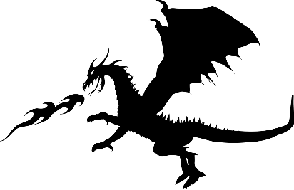6 Enemies could each have 20, etc.

## Difficulty

* **Easy** Combat (about 1-3 rounds of combat)
  + Enemy Health = 10 per Player Level
  + -1 to all your rolls
* **Normal** Combat (about 2-4 rounds of combat)
  + Enemy Health = 12 per Player Level | Don’t change rolls
* **Hard** Combat (about 3-5 rounds of combat)
  + Enemy Health = 15 per Player Level | +1 to all your rolls
* Parties can handle DATA GO HERE, HOW MANY EACH?

## Creating Enemies

* Make multiple types of Actions so Enemies are flexible
  + Action(s) to use on Player(s) in the Enemy’s Zone
  + Action(s) to use on Player(s) in faraway Zones
  + Telegraphed Action(s) that deal 2 rounds of damage
* Enemy Actions
  + Think about (when/why) an Enemy would do an Action
  + Actions can do anything, like dealing damage, healing Enemies, destroying the environment, etc.
  + The numbers rolled determine the Action’s value, so the damage dealt, Health healed, Zones destroyed, etc.
* Extra effects
  + Actions can cause extra effects
  + Make Zones cost 2 AP to move through
  + Move 1d6 Players to a different Zone
* Telegraphed Actions
  + Roll a die and store the number on the 1st Enemy Phase
  + On the 1st Phase, describe a buildup to the Action
  + Roll another die and add the numbers the 2nd Phase

## Sample Roll Descriptions

* **Move:** Enemies can move Xd6 Zones this Phase. With a 2, one enemy can move 2 Zones, or two enemies can move 1.
* **Grapple**: Trigger a Competing Roll, rolling 1d6.   
  If you win, the target can’t Move during the next Phase.
* **Drain**: Roll Xd6. Deal some of the total as damage to a Player and heal the rest.
* **Fireball**: Distribute Xd6 damage amongst targets in a Zone.
* **Ice Breath**: Cover Xd6 Zones with Ice.   
  Icy Zones cost 2AP to Move through.

# *Creating a Story*

## Key Moments

When creating a story, think about three key points in the story: Setup, Development, and Climax

* Setup
  + Teach Players the background of the story
  + Introduce characters and objectives
  + Hook Players into the story with an   
    attention-grabbing event
* Development
  + Develop character arcs
  + Raise the stakes of the story
  + Antagonist and/or Players progress towards their objective(s)
* Climax
  + All development merges into an epic moment
  + Returning characters
  + Display Player skills and character traits
  + After Climax, show the results of the story
* These can be used for a single quest, too!

## Preparation

* Fun stories revolve around Player decisions
* Keep basic notes on key moments in story
  + Change these notes based on Player choices
* Keep notes on Characters’ motivations and objectives

## Fantasie, Halloween, Verhaal VertellenOther Story Structures

Other methods can be used to tell stories, too. You can even tell smaller stories within a larger story! For example, maybe a character arc uses Freytag’s Pyramid during the Hook of a Hero’s Journey.

## Hero’s Journey

* Focus on character development and trials
* Meet heroes > Hook > Heroes refuse adventure >   
  Heroes meet a guide > Begin adventure > Development > Approach Climax > Climax > Reward from Climax > Aftermath > True Climax > Results of story

## Kishōtenketsu

* Good for mysteries with a strong twist
* No antagonists or conflict needed
* Setup > Development (avoid major changes) > Twist/Reveal > Aftermath of Reveal

## Freytag’s Pyramid

* Stories about drama or tragedy
* Setup > Rise (things seem to be improving) > Climax >   
  Fall (things head towards tragedy) > Catastrophe

## Fichtean Curve

* Episodic adventures or individual quest story
* Approach Crisis > Crisis (repeat as much as desired) > Climax > Results of story

Sample Characters

## Steve

* **Who**: A manly man(horse) who cuts lumber for fun
  + Eats 5 dozen eggs every morning
  + Easily scared by small insects
* **What**: Half-horse, half-man that wears two pairs of jeans (one for his rear legs and one for his front legs)
  + Wears a thick, red flannel with rolled up sleeves
  + Smiles bright enough to light up the woods at night
* **Where**: He lives alone in a cottage in the woods
  + He was outcast by the nearby town for how hideous he looked with braces in his youth
* **When**: He is in his prime…age, at least
  + Fully grown, but very immature and childish
* **Why**: He ran from his cottage, asking for help because a giant spider was scaring him (it seems like he’s a big baby and is exaggerating the spider’s size, but it is indeed a giant spider)
* **How**: He frequently gallops, as if in slow motion

## D.A.D. – Deadly Autonomous Drone

* **Who**: A humanoid, sentient robot armed with numerous deadly weapons inside its torso

## Sushe

* **Who**: A dwarf that handles the town’s request board
  + Maintains a board filled with many documents
* **What**: 3.5 foot tall dwarf
  + Dresses in fancy clothing
  + Wears a monocle that frequently falls off
* **Where**: In town, frequently traveling back and forth between the request board and their home
* **When**: Young for a dwarf, only 50 years old!
* **Why**: Once dreamed of being an adventurer
  + Got terrified by their first goblin and decided to work in town instead
* **How**: Always in a hurry, but eager to stop and inform whoever has a question

## Marun McCullough

* **Who**: A fairy that runs a local ice cream shop

**Ice Cream Flavors**

Archer Almond Barbarian Blueberry

Bard Bubblegum Villain Vanilla  
Clerical Cookie Dough Druid Dark Chocolate

Fightin’ Fudge Monk Mint

Paladin Pecan Ranger Rocky Road

Roguish Raspberry Sorcerer Strawberry

Warlock Wild Surprise Wizard Walnut

# Sample Enemies

**Goblin**

A short, green creature with tall, pointy ears, gnarled teeth, and bright, yellow eyes.

They often attack in groups and try to surround their prey.

**Movement:** Goblins will try to surround their prey.

**Claws:** Deal Xd6 damage to a Player in your Zone.

**Improvised Projectile:** Deal Xd6 to a Player.

**Latch-On:** (Telegraphed)Phase 1: Store 1d6. Goblin crouches, staring intently at 1 Player.  
Phase 2: Roll 2d6. Trigger a Competing Roll. If you win, you latch onto the targeted Player’s face, preventing ranged Actions. Goblin can’t do any Actions while latched on.

**Goblin Boss**

A slightly less short Goblin, this boss has proven to be much stronger than the other Goblins it lives with, ordering them around and holding a sense of authority over them.

**Movement:** It will increase nearby Goblins’ movement by throwing them.

**Hurl Goblin:** Deal Xd6 damage to a Player by throwing a Goblin at them.

**Headbutt:** DealXd6damage to a Player in your Zone, preventing them from using an Action twice until the next Enemy Phase.

**Call Reinforcements:** (Telegraphed) P!: Roll 1d6. Next Phase, that many Goblins will join the battle.   
P2: Roll Xd6. Add the total to the Enemy Health Pool.

**Shadow Goblin**

A goblin-like creature that is entirely black with dark, red eyes. They often attack in groups and will sink into a shadow on the ground once attacked.

*Note:**This enemy should be used in groups.*

**Movement:** After taking damage, it can sink into the ground. While in the ground, it can’t *take or deal damage*.

**Rise:** Move Xd6 Zones and rise from the ground.

**Claws:** Deal Xd6 damage to a Player in your Zone.

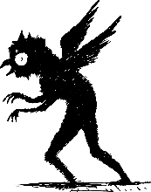

**Enchanted Armor**

A magically enchanted suit of armor that moves without a body! It tries to ensnare victims in itself to absorb their life force. If the Armor is defeated, the trapped creature is freed.

*Note: It can’t move while it has a character ensnared.*

*Note: Avoid using more than 1 of these in a single combat.*

**Movement**: Whenever this enemy takes damage, it faces whoever attacked it and moves toward them.

**Ensnare:** If the Enchanted Armor is in the Zone of a player who attacked it, it ensnares* them.

*If a player is ensnared, they can still damage the Enchanted Armor, but they cannot move away from it, help, or heal their allies. An ensnared creature isn’t free until the Armor is defeated.

**Absorb:** Deal some of Xd6 damage to an *ensnared* character. Heal the rest.

# Sample Items

* (**1** AP)**Fast Potion**: Heal 1 Health per Level
* (**2** AP)**Potion**: Heal 3 Health per Level.
* (**3** AP)**Slow Shield**: Heal 4 Health per Level.  
  You can use this heal above your maximum Health, up to 10 Health above your maximum.
* (**4** AP)**Turret**: Drop a turret in your Zone that has Health equal to your level. When an enemy enters the turret’s Zone, it deals damage equal to your level to that enemy.
* (**1** AP)**6-Pocket Grab-Bag**: Reach into one of the 6 pockets, which each holds a random Item. You can only use this Bag 6 times before it vanishes. Roll 1d6 to see which Item is there:
  + 1: A handful of marbles
  + 2: A handful of Bees
  + 3: A rock the size of your palm
  + 4: A kitten the size of your palm
  + 5: A torch that stays lit for 12 hours and cannot be extinguished; its fire also does not harm any who touch it
  + 6: A sentient, duck-sized robot that will do your bidding for 1 hour before exploding
* (**3** AP)**Jug of Mysterious Liquids**: Twice a day, you can use this Jug to create a gallon of one the following liquids:
  + Acid, Alcohol, Mayonnaise, Water, Oil, Molasses
  + In combat, it creates enough of the liquid to coat the ground of an entire Zone.
* (**0** AP)**Communication Earpiece**: Allows the user to communicate at a whisper through someone else’s Earpiece if that person is within range of this Earpiece.

## Custom Items